**Project Report: Interactive Language-Learning Book**

International Balkan University

Senanur Emin Diner Kafeci Viktorija Angelovska

23 Dec 2025

Skopje, North Macedonia

**Aim of the Project**

The aim of this project was to create an interactive book for children who are just starting to read and learn new words. The goal was to make the learning process easier and more enjoyable by incorporating visual and interactive elements, enabling children to associate words with images and animations. This approach is intended to foster a fun and engaging learning environment for young learners.

**Implementation Details**

**Form 1: Title Page**

**The purpose of Form1 is to serve as the main screen for your interactive book application. This form includes graphical elements such as images, lines, and a moving bee animation, along with navigation functionality to move to the next form.**

**Key Components**

**1. Form Initialization**

* The **Form1 constructor** initializes the form:
  + InitializeComponent() sets up the form layout.

**2. Paint Event**

The Form1_Paint method is responsible for drawing custom graphics on the form, such as images, lines, and shadows.

* **Background Image**:  
  Displays an image (bearandbee.PNG) stretched to fit most of the form’s client area.
* **Lines**:  
  Two black lines are drawn to represent a page-corner fold:
  + One line is vertical; the other is horizontal.
* **Shadow Effect**:  
  A blurred shadow is drawn near the "page corner" using semi-transparent black lines.
* **Navigation Icon**:  
  Adds a clickable **PictureBox** (right.png) to navigate to the next form (Form2).
  + The PictureBox_Click event opens Form2 and hides Form1.

**3. Navigation to Form2**

When the navigation icon is clicked:

* The **PictureBox_Click** method:
  + Creates a new instance of **Form2** and shows it.
  + Hides **Form1** to focus on the next form.

**4. Bee Animation**

A moving bee is displayed in a circular path using a Timer.

* **Form1_Load Method**:
  + Initializes the bee's image (bee03.PNG) in a **PictureBox**.
  + Calculates the circular path’s center and sets the initial bee position.
  + Starts a Timer for smooth animation.
* **Bee Movement Logic**:
  + The BeeTimer_Tick method is triggered at regular intervals (50ms).
  + Updates the bee's position on the circular path:
    - Uses trigonometric functions (Cos and Sin) to calculate coordinates.
  + Resets the angle to avoid overflow after a complete circle.

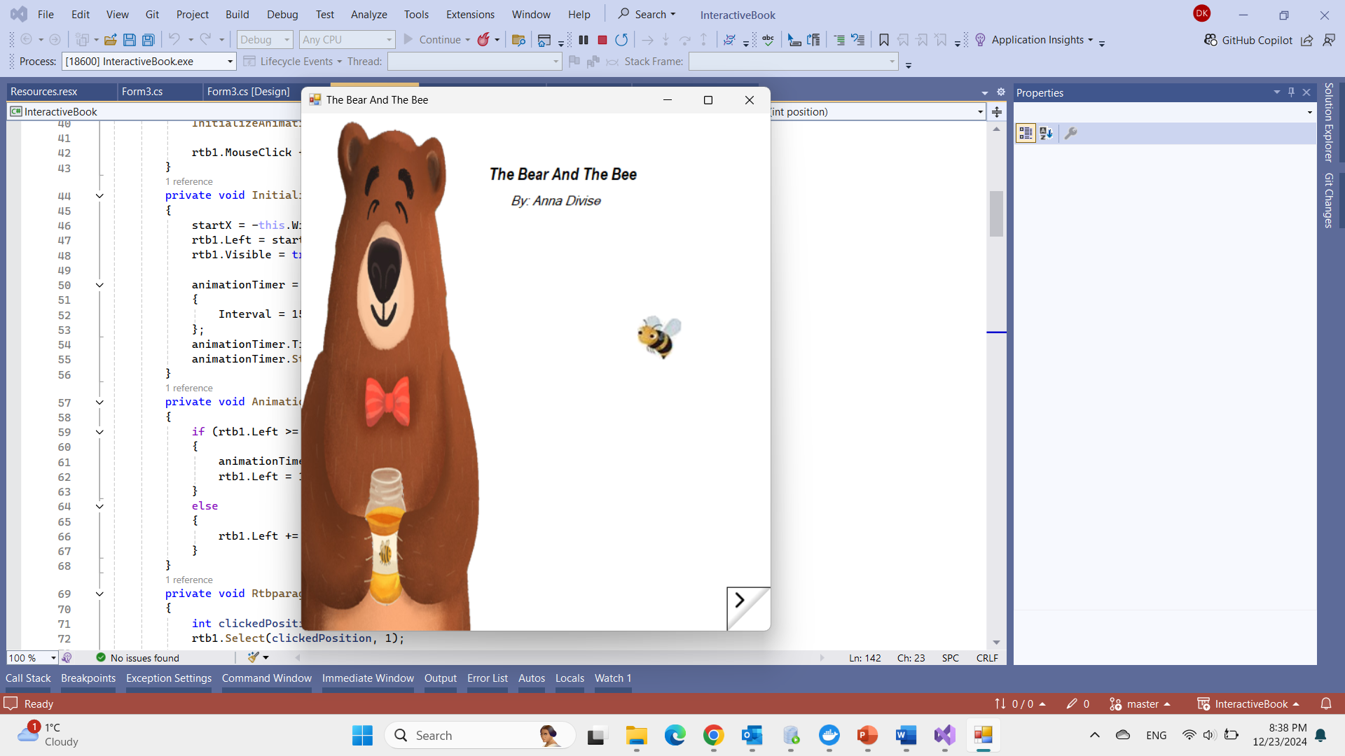**Code Highlights**

**1. Timer for Bee Movement**

* The bee animation is achieved by:
  + Incrementing an angle on each Tick event.
  + Calculating the x and y coordinates based on the angle using circular motion formulas.

**2. Graphics Drawing**

* Custom graphics (lines and shadow effects) are drawn using the Graphics object in the PaintEventArgs.

**3. Navigation**

* The PictureBox element is interactive:
  + Clicking it triggers an event to navigate to **Form2**.

**Form 2: Interactive Word Learning Page**

Form2 is part of an interactive application that displays a story and allows users to click on words in the text to trigger images or animations. The form features a text box (rtb1) where the story is shown, and clicking on certain words triggers corresponding images or animated GIFs.

**Key Components**

**1. Fields:**

* **animationTimer**: A Timer object used for animating the movement of the text box (rtb1).
* **startX**: The starting X-coordinate for the animation (off-screen).

**2. Form2 Constructor (Form2):**

* Initializes the form and components (InitializeComponent).
* **rtb1.Text**: Sets the text content of the RichTextBox (rtb1) with a story.
* **HighlightWord**: Highlights specific words in the story by calling HighlightWord method for each word with a defined color (e.g., "bear" is highlighted in orange).
* **rtb1.Visible = false**: Initially hides the RichTextBox.
* **InitializeAnimation**: Calls a method to set up the animation for rtb1.

**3. Form2_Load Method (Form2_Load):**

* Triggered when the form is loaded. It sets the initial properties for rtb1 and starts the animation by calling InitializeAnimation.
* Adds a mouse click event handler (rtb1.MouseClick) that triggers actions when a user clicks on a word in the text.

**4. InitializeAnimation Method:**

* Sets the initial position of the rtb1 text box off-screen (startX = -this.Width).
* Makes rtb1 visible and begins the animation timer (animationTimer), which will move rtb1 from off-screen to its final position.

**5. AnimationTimer_Tick Method:**

* This method is called on each tick of the animation timer.
* It moves the rtb1 text box incrementally to the right, and stops once it reaches its final position (close to left = 15).
* The speed of the animation is controlled by adjusting the Interval of the animationTimer.

**6. Rtbparagraph1_MouseClick Method:**

* This method handles the mouse click event on the RichTextBox (rtb1).
* **GetCharIndexFromPosition**: Gets the character index at the clicked position.
* **GetWordAtPosition**: Extracts the word clicked by the user based on the character index.
* Based on the clicked word, it triggers specific actions (e.g., displaying an image or animated GIF) using the ShowImage or ShowAnimatedGif methods.

**7. GetWordAtPosition Method:**

* Given a position (clicked character index), it finds the full word at that position by expanding in both directions (left and right) until non-alphanumeric characters are encountered.

**8. ShowImage Method:**

* Displays a static image in a new form.
* A PictureBox is used to load and display the image, and the image is resized to fit within the form (SizeMode = StretchImage).
* The image is shown in a separate form (imageForm), which is displayed to the user when triggered by a click on a word.

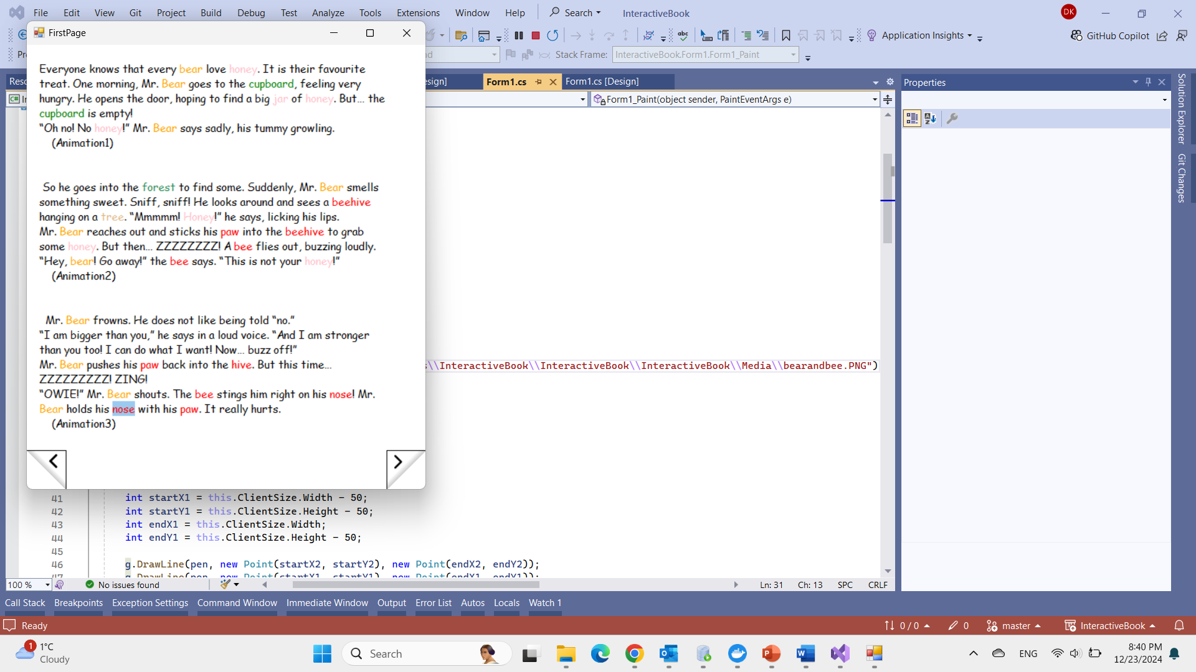**9. ShowAnimatedGif Method:**

* Displays an animated GIF in a new form.
* A PictureBox is used to load the GIF, and ImageAnimator is used to ensure that the animation is continuously updated and shown.
* The GIF is displayed in a separate form (gifForm) that allows the user to see the animation.

**10. HighlightWord Method:**

* This method highlights occurrences of a given word in the rtb1 text by selecting each occurrence and changing its color (SelectionColor).
* It searches for the word by calling IndexOf to find the start index of each occurrence and then selects the word by its length.

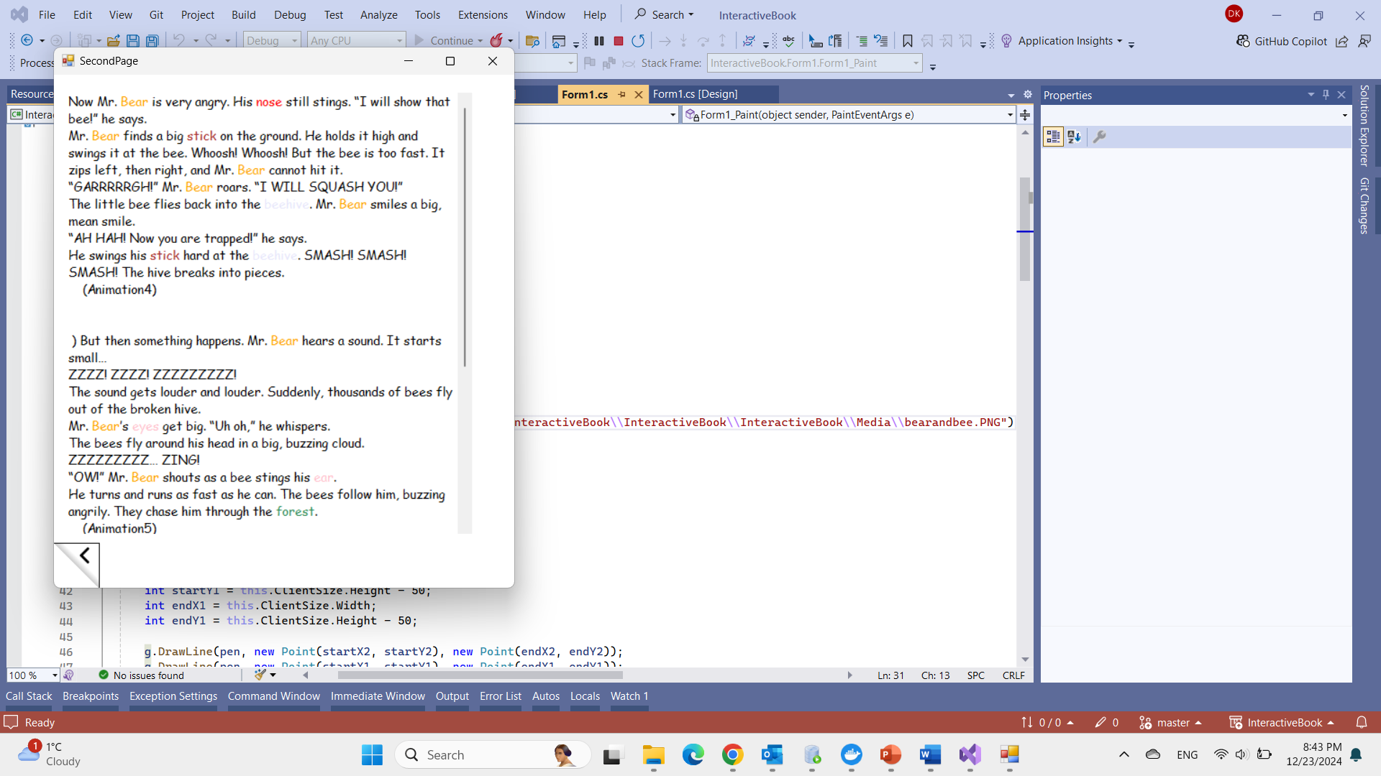**Form 3:**

Form 3 is similar in structure and functionality to Form 2.

Key Features of Form 3:

* Displays a paragraph in a clear and readable format.
* Includes animations that visually depict the content of the paragraph when clicked.
* Provides navigation buttons to move to the previous or next page of the book.

**Github Link**

[**https://github.com/DinerKafeci/InteractiveBook**](https://github.com/DinerKafeci/InteractiveBook)

**User Guide**

* Download the zip file of the code,
* If you do not have Visual Studio, download and install Community Edition for free from this link <https://visualstudio.microsoft.com/vs/community/>
* Unzip/Extract the folder from the zip file,
* Open the ,
* Change the path adresses of the images and the animations in the code according to the your device,
* All the images and animations are in the Media folder,
* Run the code.

**Overall Project Design**

The application was developed using Visual Studio and C#, with an emphasis on simplicity and creativity in design. Each form was carefully planned and implemented to ensure a smooth and engaging user experience. Basic shapes and animations were used to create graphical representations, demonstrating effort and creativity while keeping the interface intuitive for young users.

**Conclusion**

The interactive language-learning book successfully achieves its goal of making learning new words and reading more enjoyable for children. By combining visual elements, animations, and interactive features, the project provides an engaging platform for early learners. This project demonstrates the practical application of computer graphics principles to create an educational tool that is both functional and appealing to its target audience.

**References**

* The story : <https://www.youtube.com/watch?v=jKi2SvWOCXc>
* Assistance and help : ChatGPT
* Animation ideas : <https://www.youtube.com/watch?v=rJq9sYE0FpY>
  + <https://www.youtube.com/watch?v=eRZt4RuHG-M>
* Gif Cutting : <https://www.youtube.com/watch?v=up7HZuLa_zI>
  + Canva
  + Giphy